The Cognos HR Scored: Measuring Success in Talent Management

Name: Sathiya Rubha M

NM Id: au611220104134

# Step 1: Upload the data

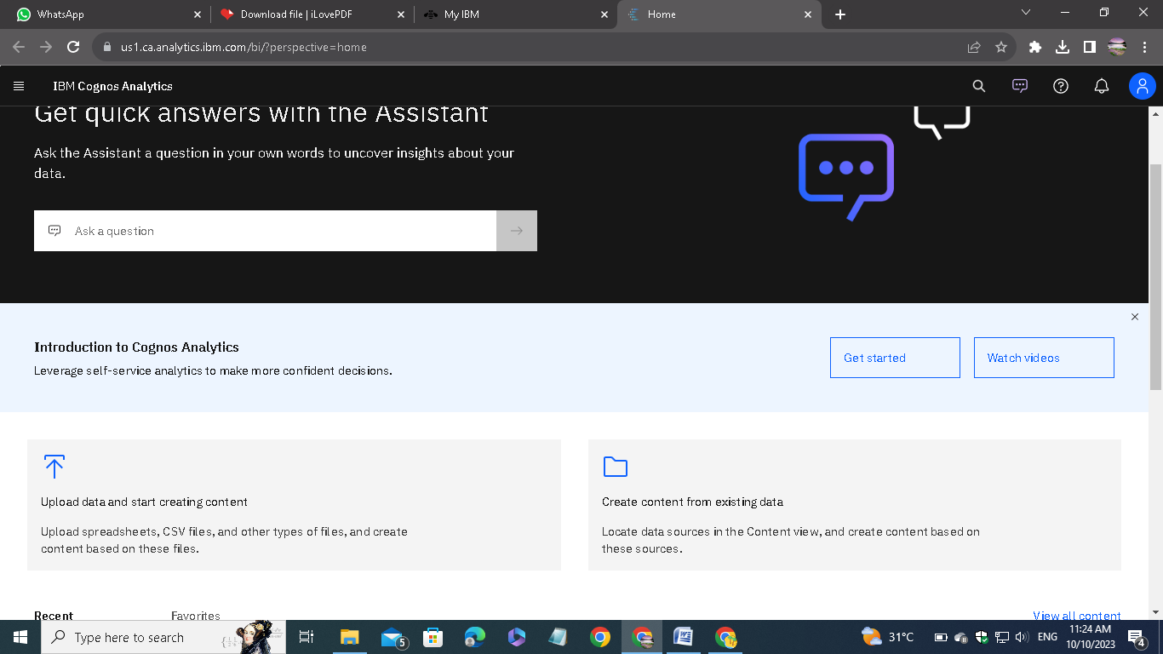

Open IBM Cognos Analytics. Then choose upload data.

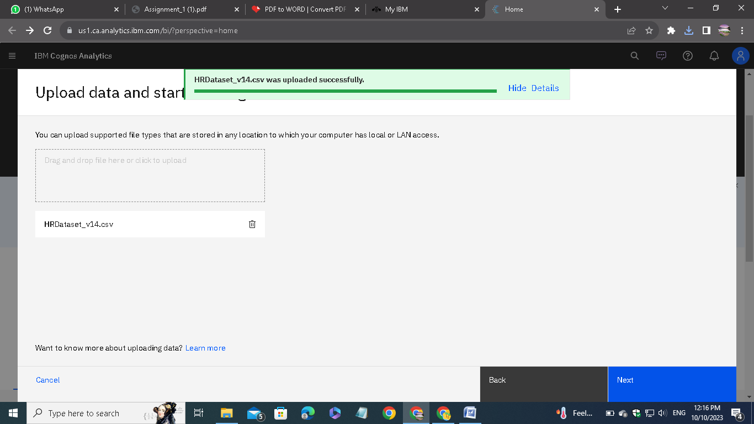

Upload the csv data file which we downloaded from the given link on the assignment.

# Step 2: Preparing:

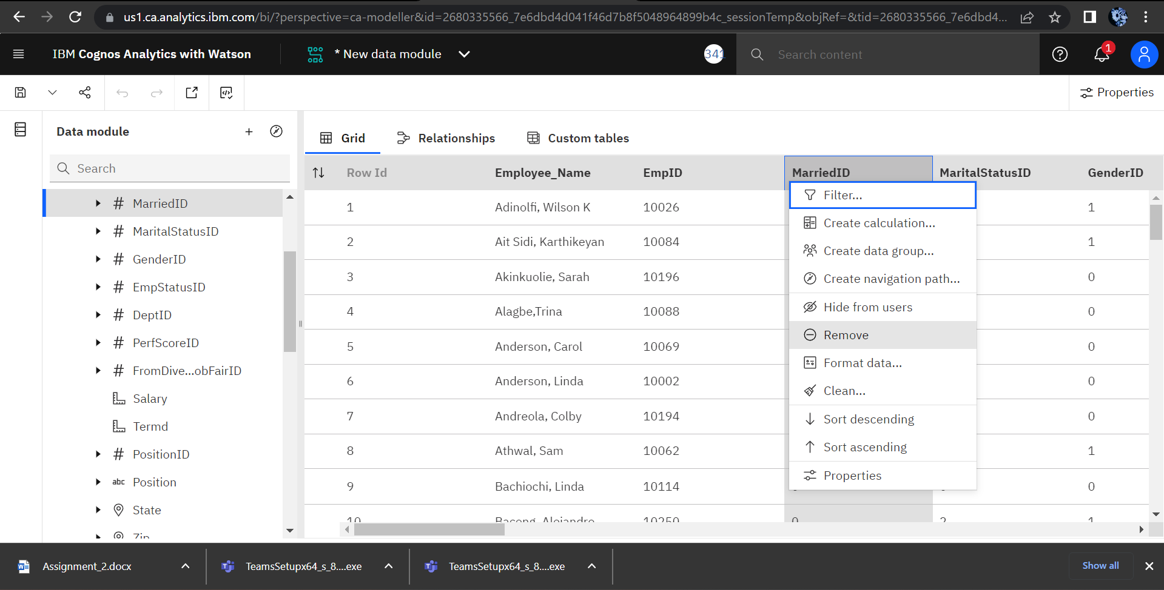

Remove the unnecessary columns and check for the missing values. In my case, there is no missing case.

After removing, save the new data module in a required name.

# Step 3: Exploring the data

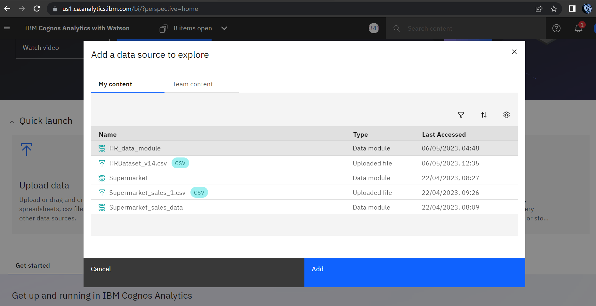

Go to explorations given in the menu and open the saved data module.

Then Select and add the data module that you want for the exploration.

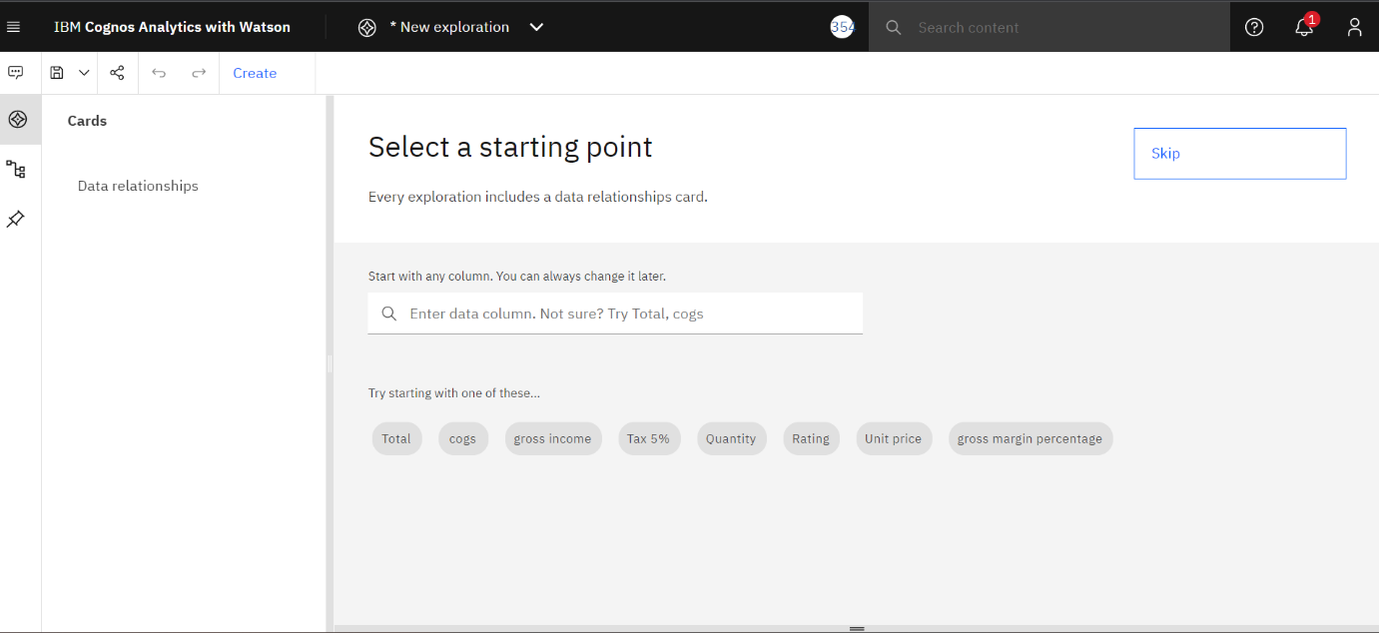

Click on create and select a card style. In my case, I have chosen the single visualization.

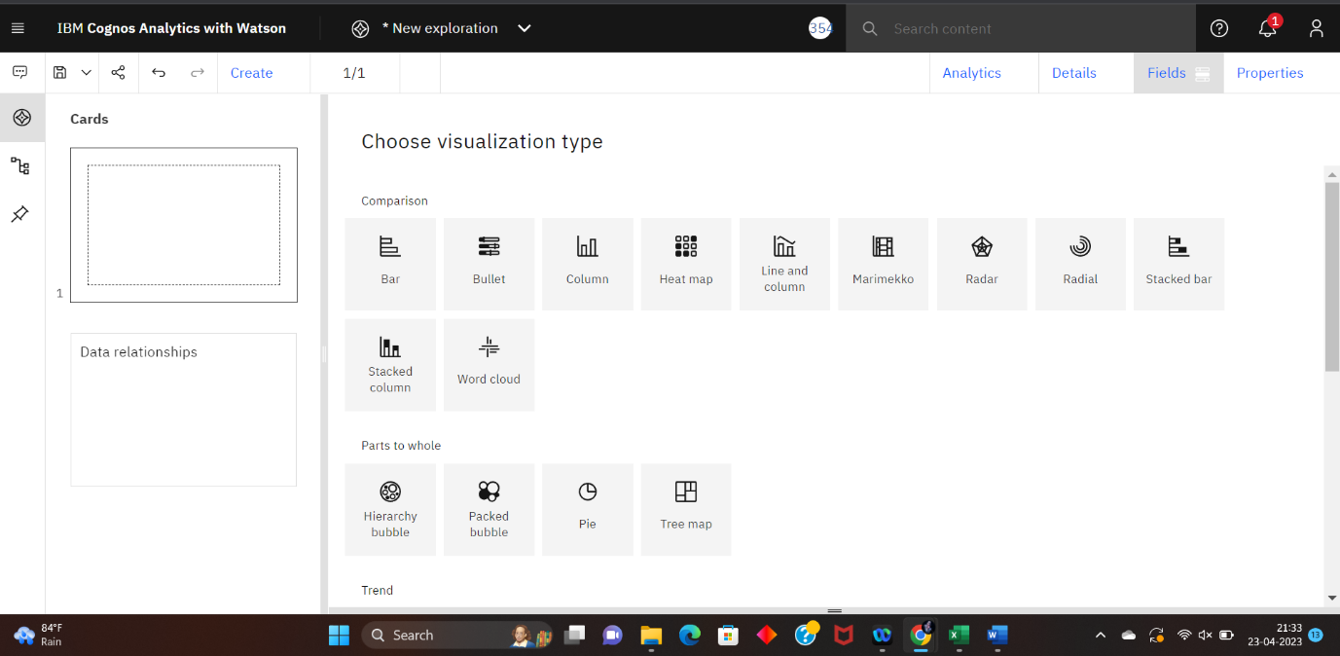

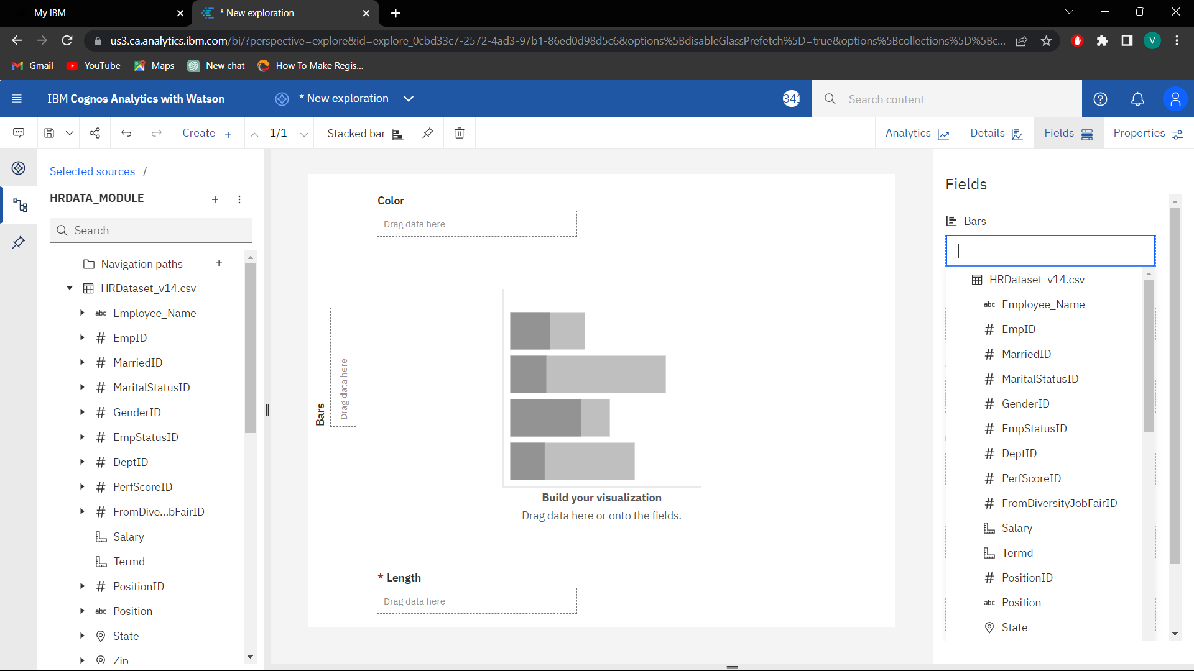

Then choose the type of the visualization. Each type of visualization is used for different needs.

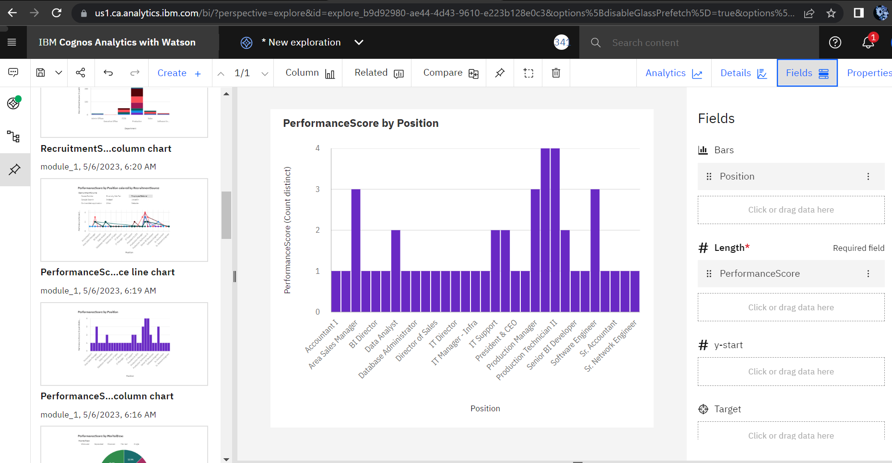

In the fields, we have to mention the attributes for the x-axis, y-axis and colors.

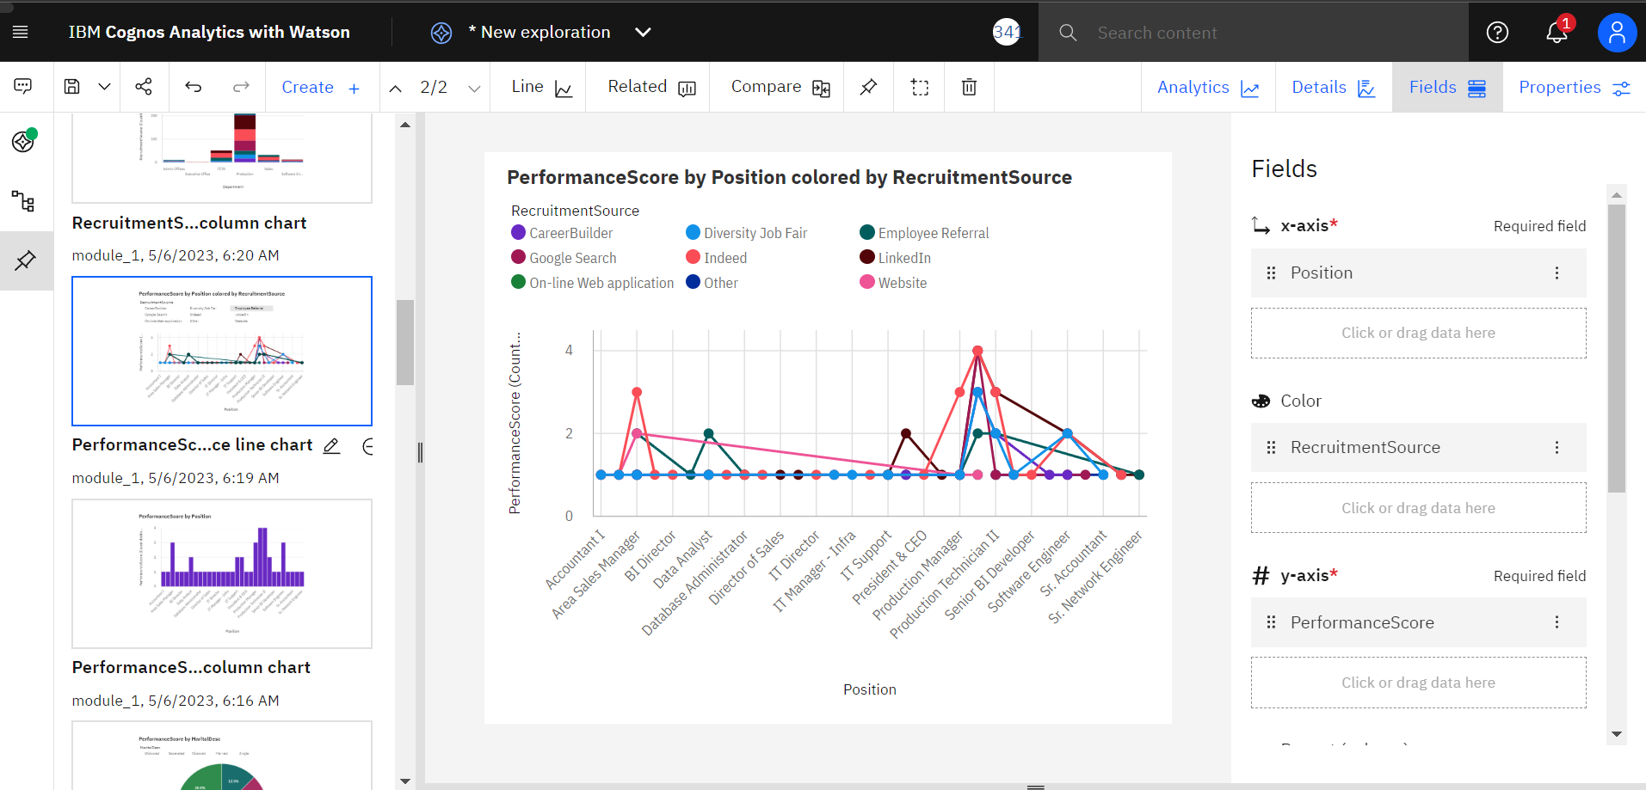

After exploring save it in a required name.

# Step 4: Dashboarding

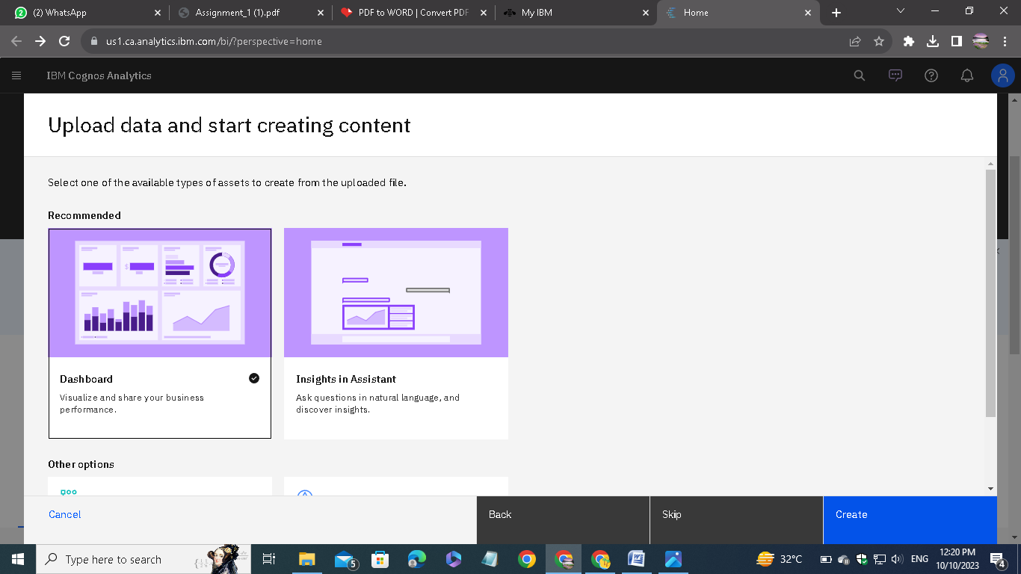

Go to the present data option to visualize the explored data in different format

Select the type of presentation, in my case I am using dashboard.

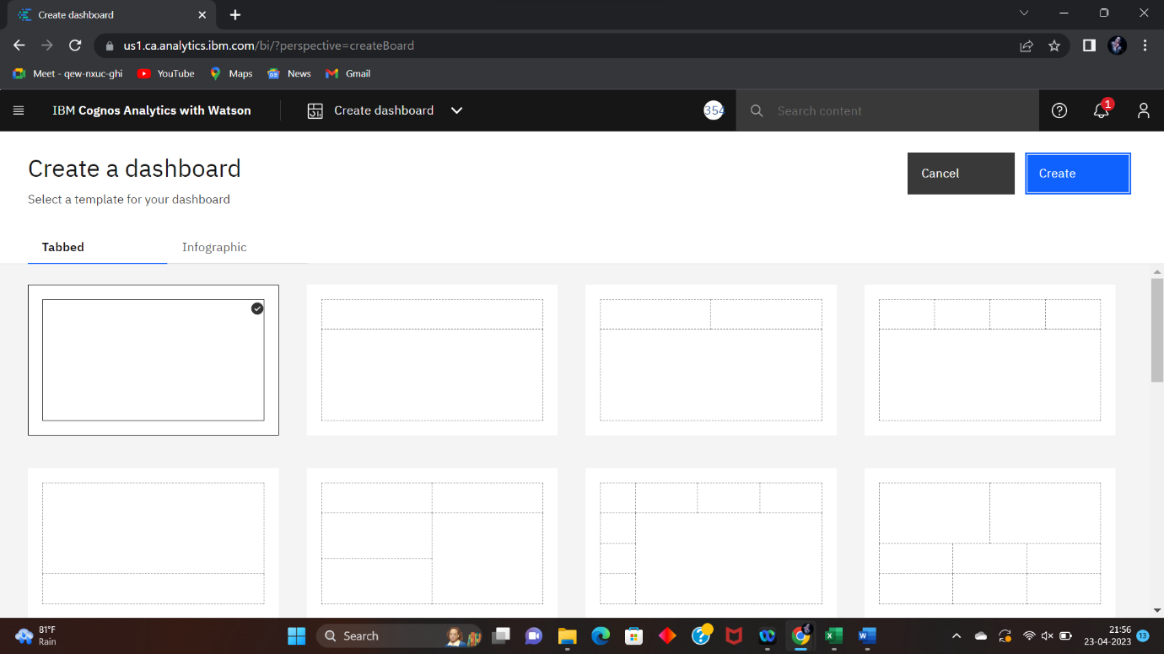

Select the type of dashboard.

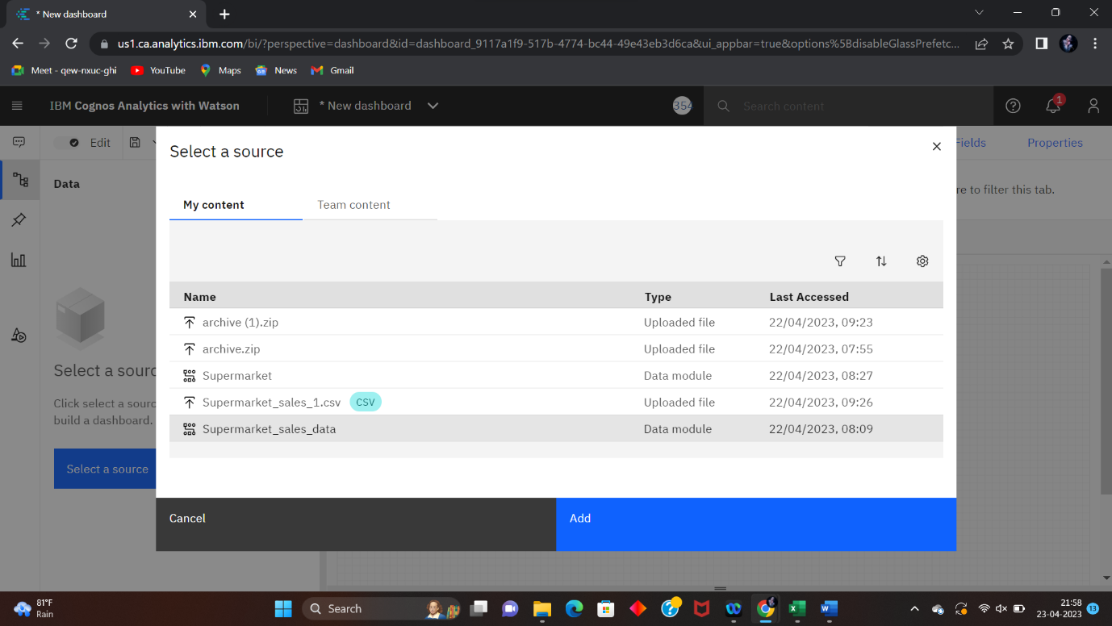

After selecting the type of dashboard click on “select a source” button to add the source file to the dashboard.

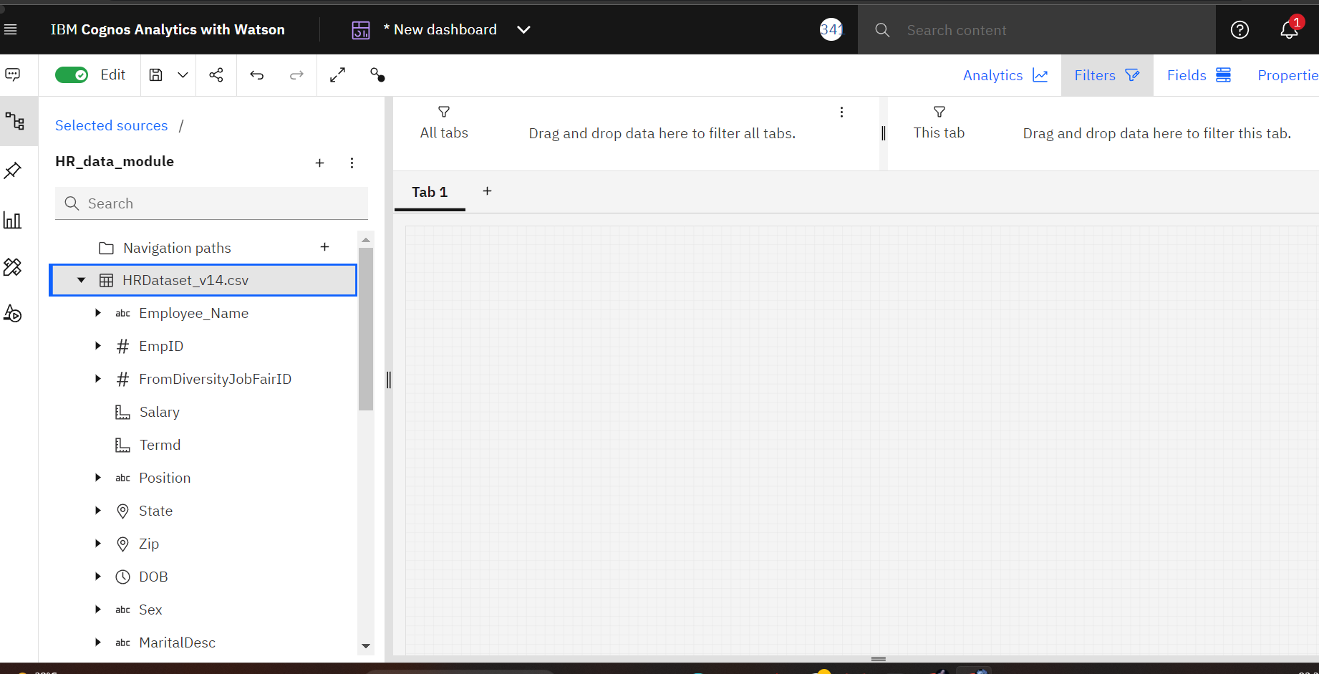

Adjust the dashboard settings for our convenience.

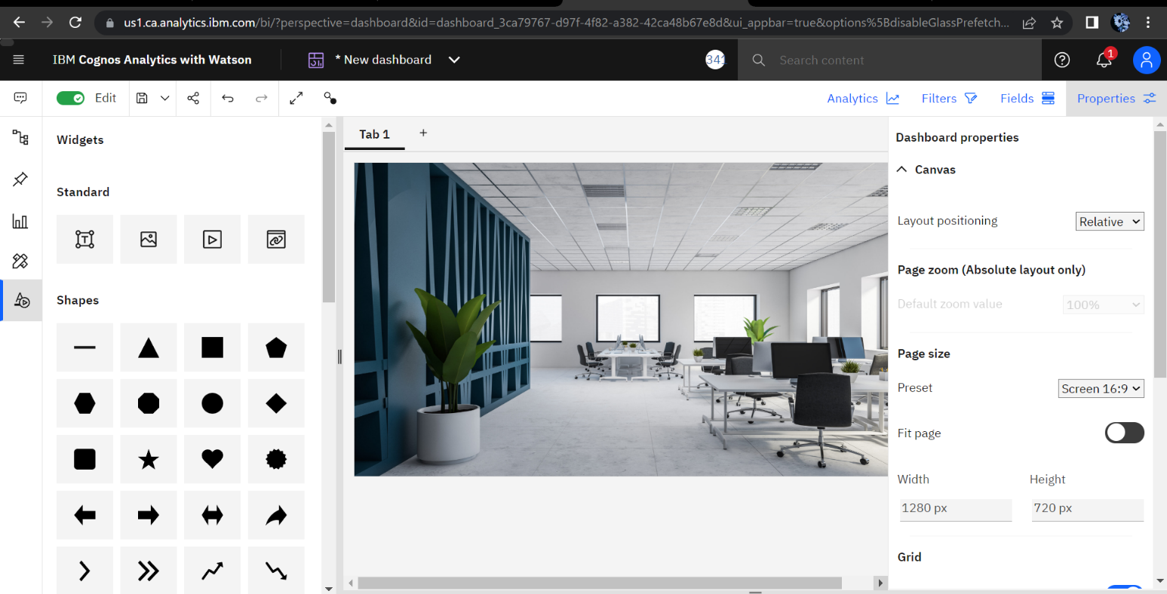

Choose the type of dashboard.

Add the source file to the dashboard.

Adjust the dashboard settings for our convenience.

We can able to directly drag the data from the source or we can also able to plot our exploration directly from the pinned things.

Change the tab name for our reference.

After that save the presentation. These steps are followed for all other tabs. Finally, we get the visualization of our analytics.

Using share option, we can able to share our presentation as direct link or embed code

______________________________________________________________________

Here I am attaching the screenshots of all the tabs I created:

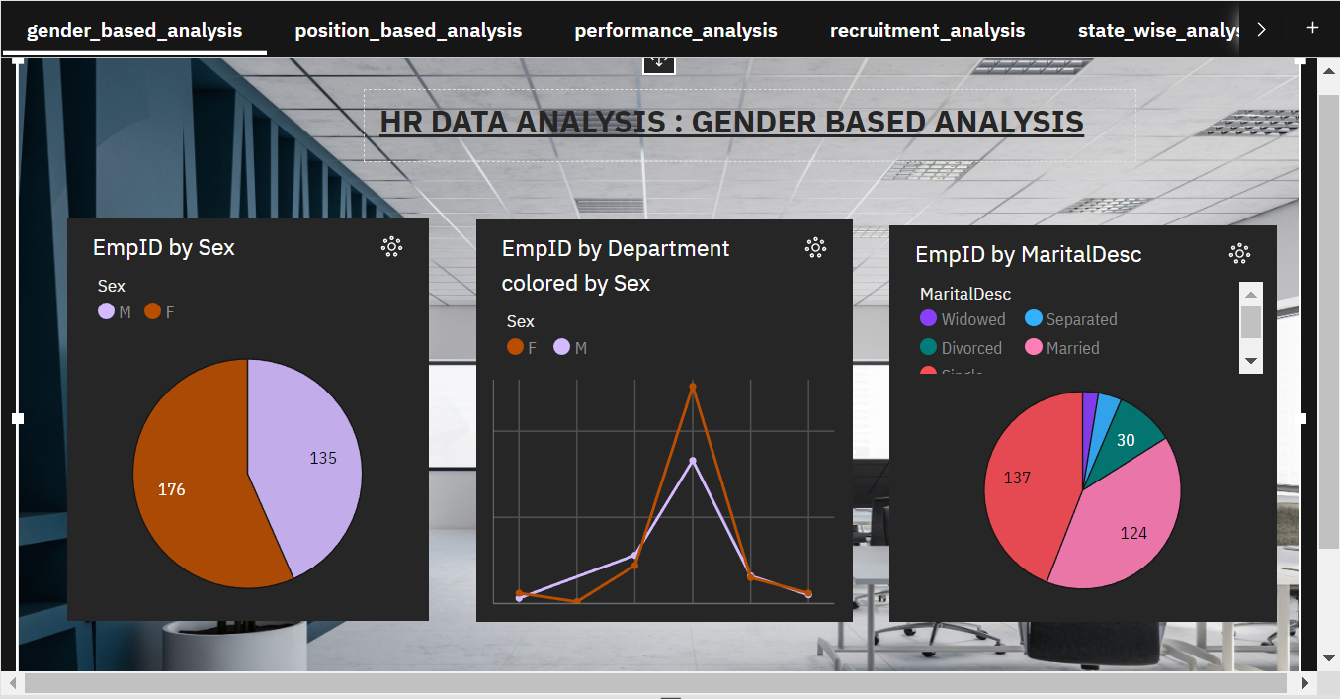

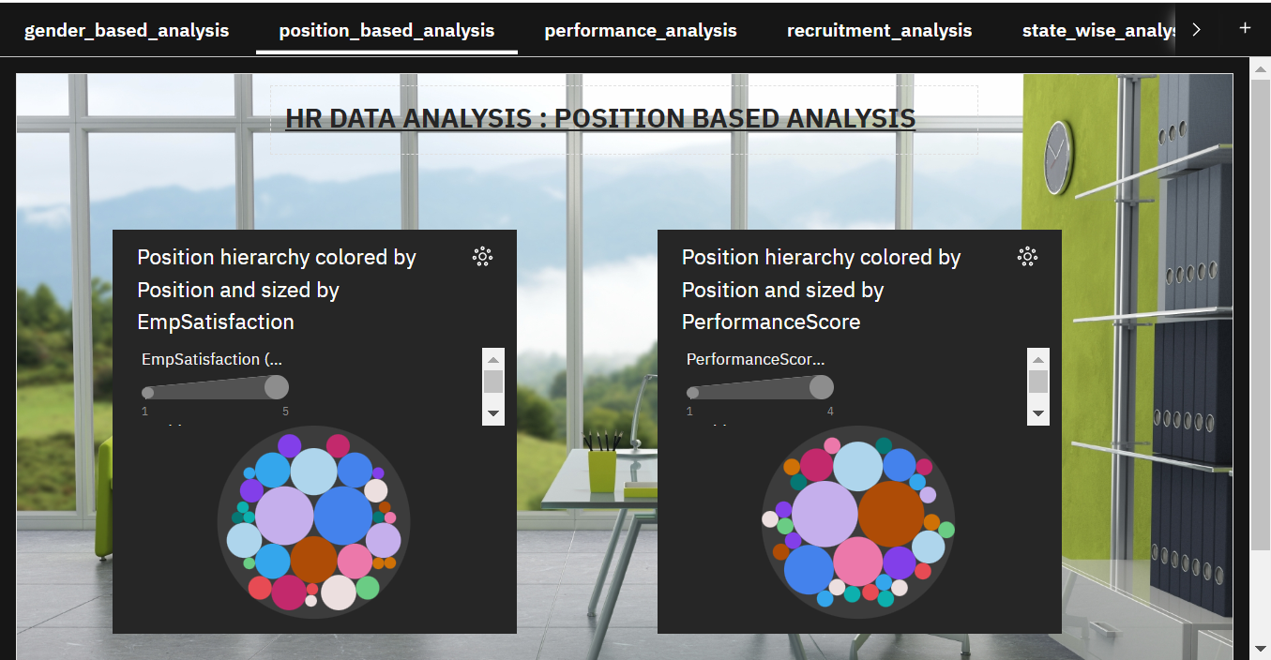

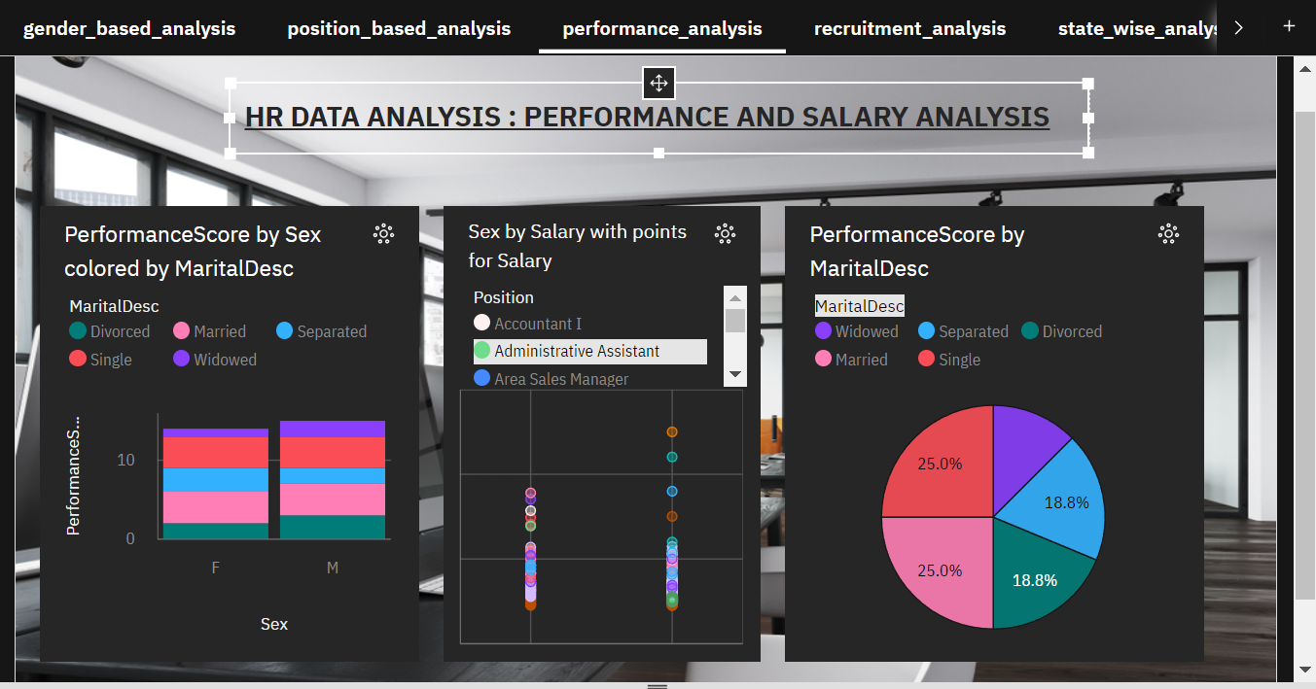

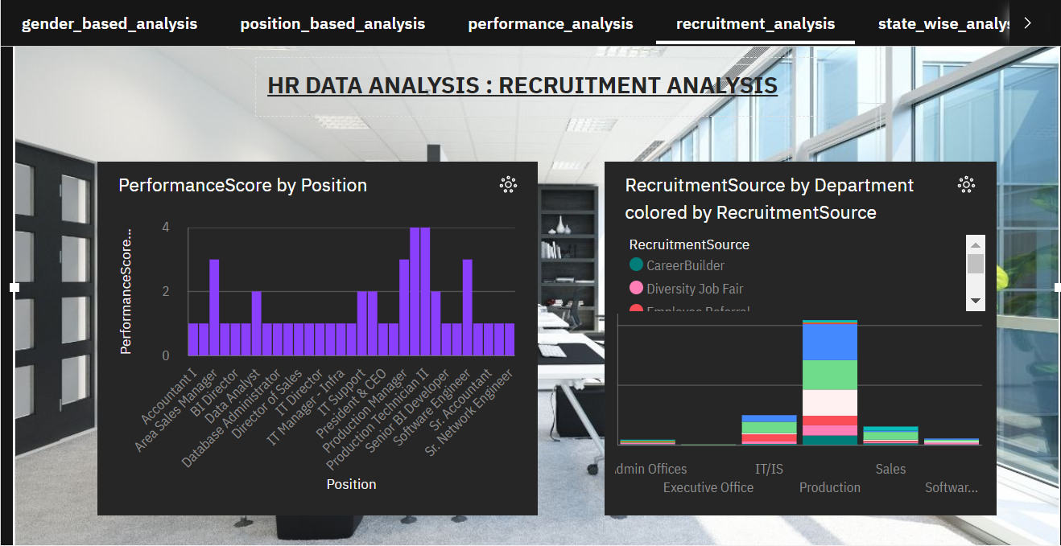

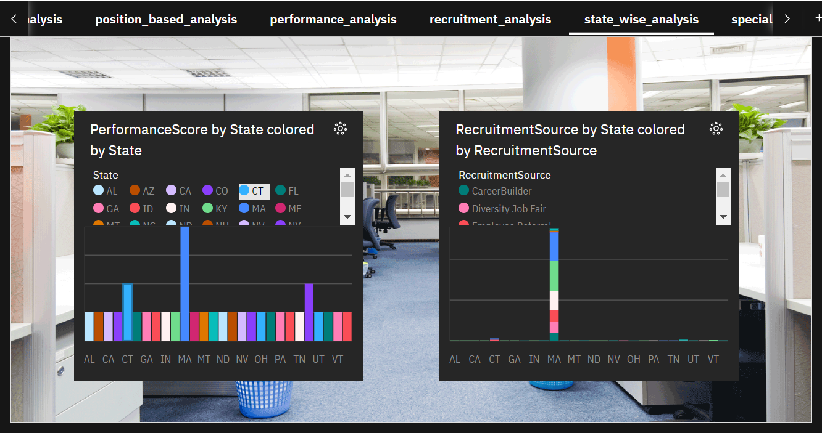

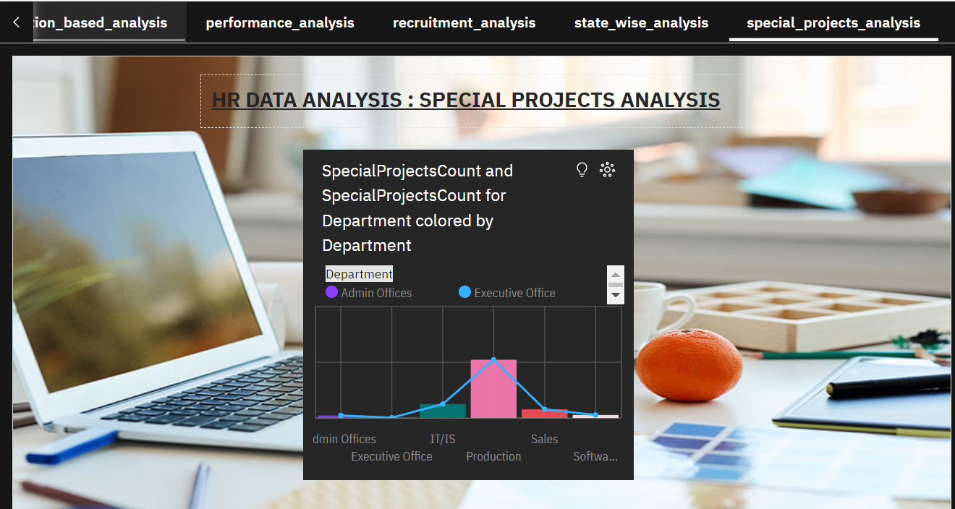

Here is the link for the presentation: https://us3.ca.analytics.ibm.com/bi/?perspective=dashboard&pathRef=.my_folders%2FHRDATA_DASHBOARD&action=view&mode=dashboard&subView=model00000187eff70841_00000003

# Step 5: Creating Reporting:

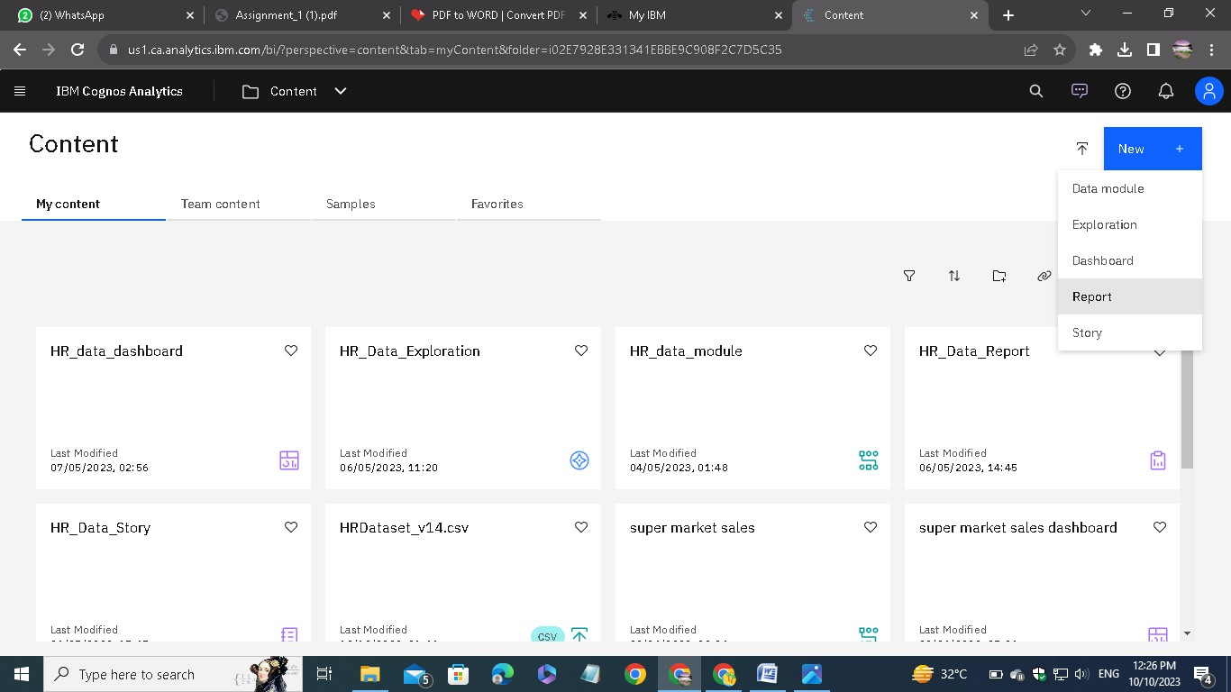

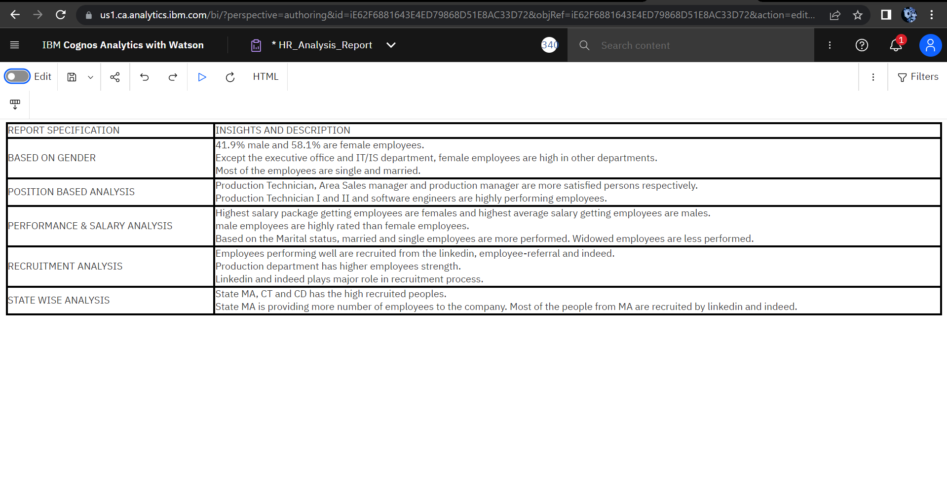

After creating report, we can run using multiple options. Here I am running as PDF

Step 6: Creating story

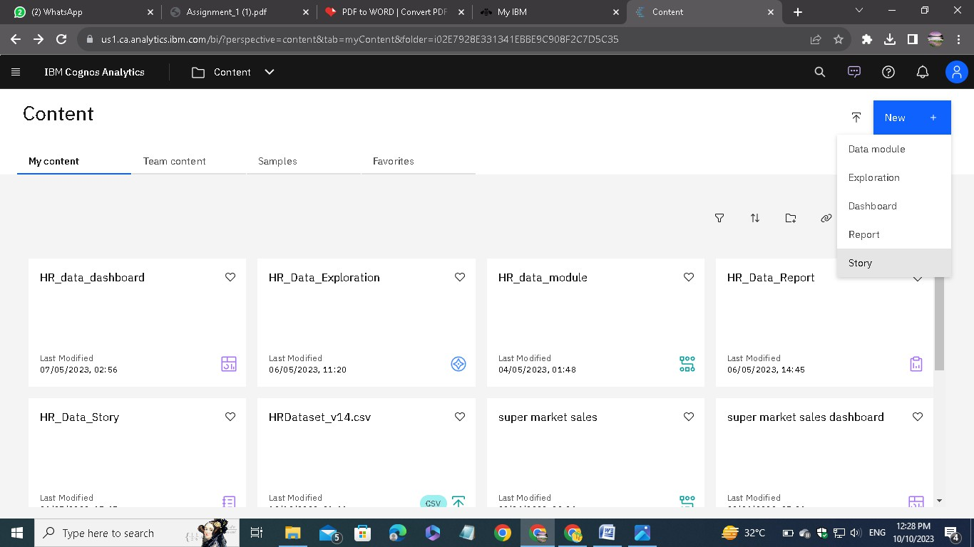

To create a story, choose the Present data.

Then choose story option.

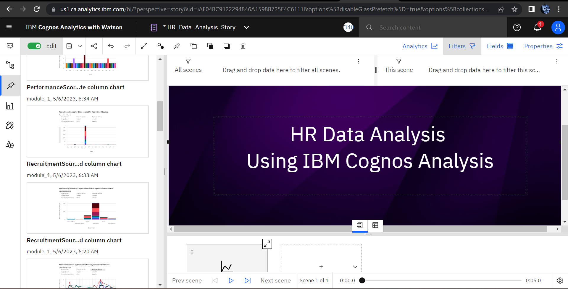

These tools are similar to the other presentation creating tools.



Here is the completed Story:

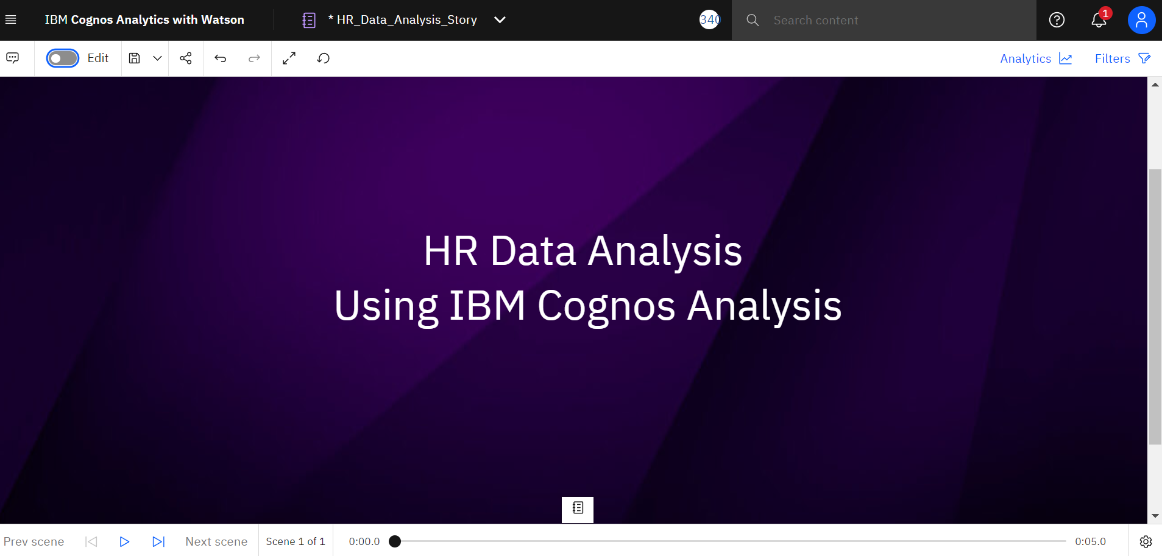

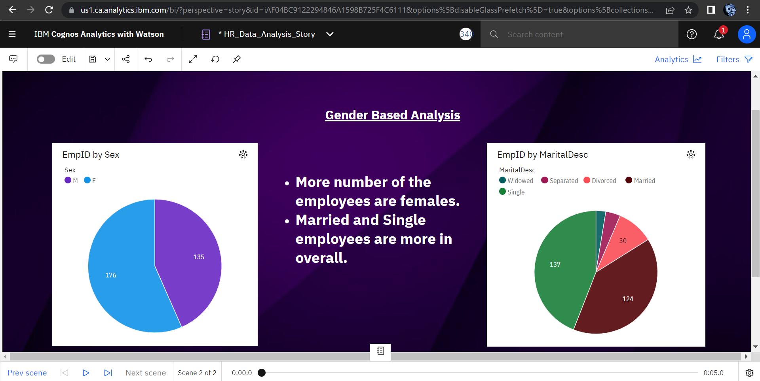

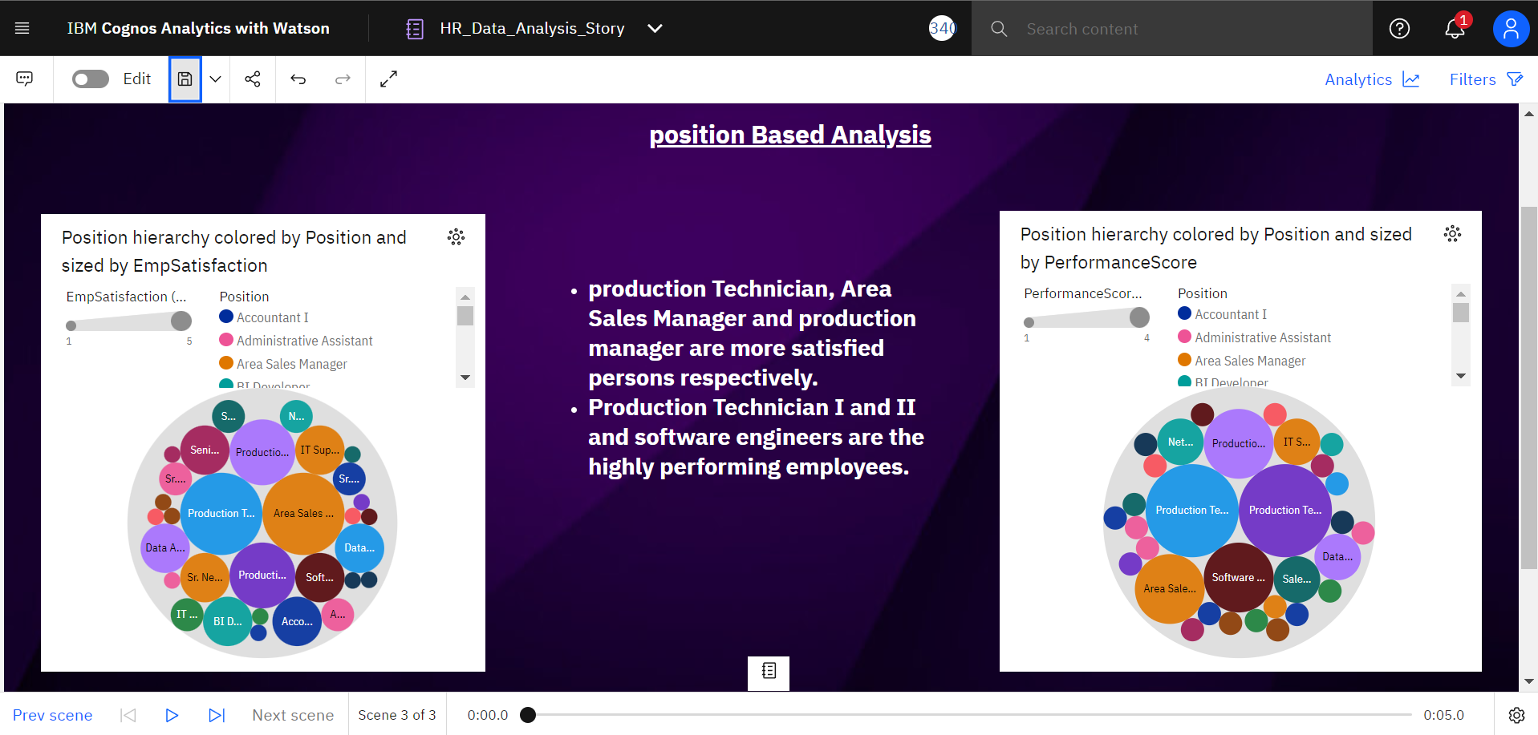

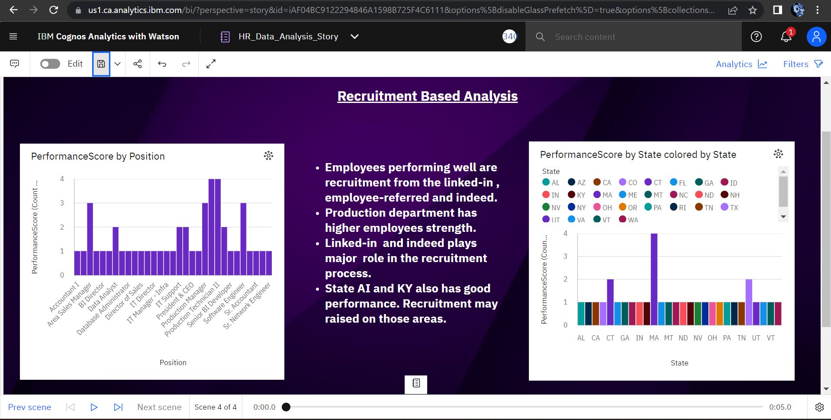

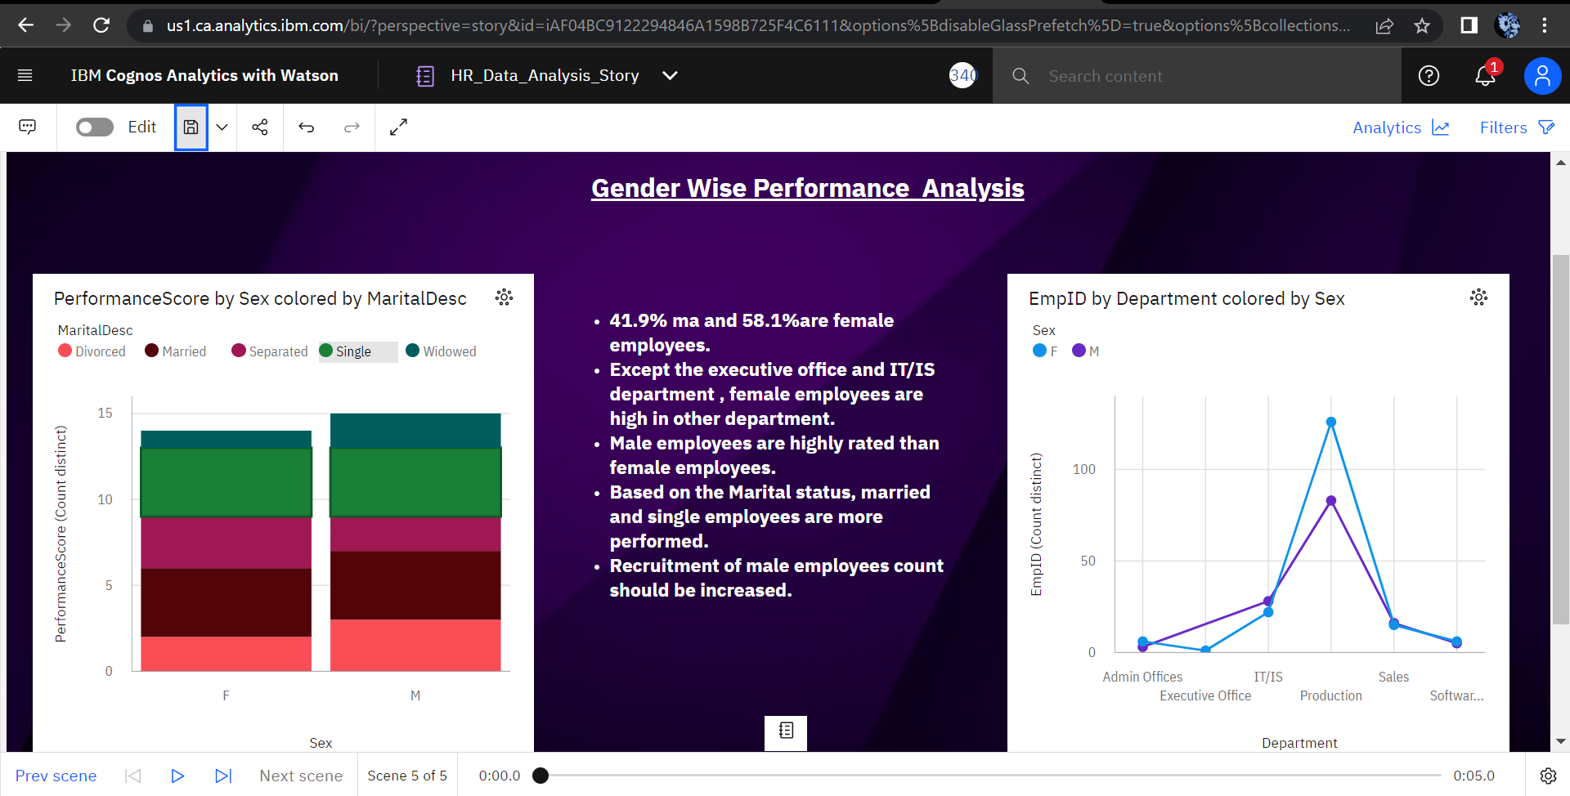

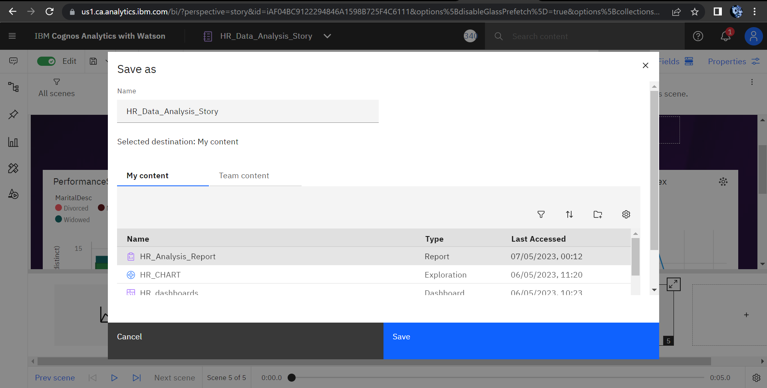

Save the story as per the required name. Finally make sure everything has been save.